GROCERY WEB APPLICATION

**SMART BRIDGE EXTERNSHIP**

**MODERN APPLICATION DEVELOPMENT**

#### (Java Spring Boot)

*Submitted by*

B.RANGA SAI SIDDARTHA - 20MIS7068

T V N HARSHAVARDHAN - 20MIS7038

J HARSHA SRIKANTH - 20MIS7045

A V DHANUSH - 20MIS7058



#### TEAM PROJECT BY

#### VIT-AP UNIVERSITY AMARAVATI

**ANDHRA PRADESH, INDIA 2023**

**ABSTRACT**

The Grocery Web Application is a modern solution developed using Java Spring Boot for efficient and convenient online grocery shopping. This report explores the project's overview, purpose, proposed solution, theoretical analysis, experimental investigations, flowchart, advantages, disadvantages, applications, conclusion, future scope, and references.

The application leverages the Java Spring Boot framework to deliver a robust and scalable platform. It offers users the convenience of shopping for groceries online, a wide product range, personalized experiences, and efficient order management. However, it also has limitations such as dependence on internet connectivity and limited physical inspection of products.

The Grocery Web Application finds applications in online grocery stores, supermarkets, local grocery shops, mobile grocery delivery services, corporate cafeterias, specialty food stores, and community buying groups. It serves as a valuable tool for businesses in the grocery industry to enhance their online presence and cater to customer demands.

Future enhancements include developing a mobile application, integrating with smart home devices, improving recommendation engines, implementing real-time inventory management, and expanding payment options. These enhancements will further optimize the user experience and align the application with emerging technologies and trends.

**TABLE OF CONTENTS**

|  |  |  |  |
| --- | --- | --- | --- |
| **S. No** | **Chapter** | **Title** | **Page Number** |
| **1.** | **1.1**  **1.2** | **INTRODUCTION**  **Overview**  **Purpose** | **5**  **5**  **5** |
| **2.** | **2.1**  **2.2** | **LITERATURE SURVEY**  **Existing Problem**  **Proposed Solution** | **8** |
| **3.** | **3.1**  **3.2** | **THEORETICAL ANALYSIS and Block Diagram**  **Hardware / Software Designing** | **11**  **11** |
| **4** |  | **EXPERIMENTAL INVESTIGATIONS** |  |
| **5** |  | **FLOWCHART** |  |
| **6** |  | **RESULT** |  |
| **7** |  | **ADVANTAGES & DISADVANTAGES** |  |
| **8** |  | **APPLICATION** |  |
| **9** |  | **CONCLUSION** |  |
| **10** |  | **FUTURE SCOPE** |  |
| **11** |  | **BIBLIOGRAPHY** |  |
| **12** |  | **APPENDIX** |  |

**1 INTRODUCTION**

1.1 Overview

The Grocery Web Application is a modern application developed using the Java Spring Boot framework. It is designed to provide a convenient and efficient platform for users to purchase groceries online. The application offers a wide range of features and functionalities to enhance the overall grocery shopping experience for users.

1.2 Purpose

The purpose of the Grocery Web Application is to simplify and streamline the process of purchasing groceries. With this application, users can conveniently browse through a wide selection of products, add them to their cart, and place orders for home delivery or pickup. The application aims to offer the following benefits:

* Convenience: Users can avoid the hassle of physically visiting a grocery store by accessing the application from the comfort of their homes or offices. They can shop for groceries at any time that is convenient for them, without being restricted by store operating hours.
* Wide Product Selection: The app gives users access to a wide variety of supermarket products, including fresh produce, pantry items, household needs, and more. Users can browse different categories and brands, and select from a large assortment of things based on their tastes.
* Personalized Experience: To improve the purchasing experience, the Grocery Web Application includes personalized features. Users can create profiles and record their preferences, making it simple to reorder commonly purchased items. The application also makes recommendations based on previous purchases, assisting users in discovering new products or promotions that are relevant to their interests.
* Efficient Order Management: The application allows users to properly handle their orders. They may easily inspect their shopping baskets, change quantities, delete products, and check out. Users can also follow the status of their orders, receive updates about delivery or pickup timings, and leave feedback about their shopping experience.
* Secure Transactions: The Grocery Web Application prioritizes user transaction security. It employs industry-standard encryption algorithms to safeguard sensitive data, such as payment information, during online transactions. To provide secure and dependable payment processing, the application interfaces with reputable payment gateways.
* Responsive Design: The application is designed to be responsive, providing an optimal viewing and interaction experience across different devices, including desktop computers, laptops, tablets, and smartphones. Users can access the application on their preferred device, ensuring convenience and accessibility.

**2 LITERATURE SURVEY**

2.1 Existing Problem

The traditional method of grocery shopping involves physically visiting a grocery store, which can be time-consuming and inconvenient for many individuals. Additionally, it may be challenging for customers to navigate through crowded stores and locate specific items. This traditional approach also lacks personalized experiences and efficient order management, leading to potential dissatisfaction among customers.

Existing approaches to address these challenges include the adoption of online grocery shopping platforms. These platforms allow users to browse and purchase groceries through websites or mobile applications. However, some of these existing solutions may have limitations in terms of user experience, functionality, and scalability.

2.2 Proposed Solution

The Grocery Web Application is being developed using the Java Spring Boot framework as the proposed solution. This application seeks to overcome the constraints of existing solutions and provide users with a more enjoyable grocery shopping experience.

The following major components are included in the proposed approach or solution:

* Java Spring Boot Framework: Java Spring Boot is a powerful framework that simplifies the development of robust and scalable web applications. It provides a comprehensive set of tools and libraries for building enterprise-grade applications, including features such as dependency injection, MVC architecture, and seamless integration with databases.
* User Registration and Authentication: The Grocery Web Application allows users to create accounts and securely log in. This enables personalized experiences, order tracking, and the ability to save preferences for future purchases.
* Product Catalog Management: The application incorporates a product catalog management system that allows administrators to add, update, and manage the available grocery products. It includes features such as categorization, search functionality, and detailed product information.
* Shopping Cart and Order Management: Users can browse through the product catalog, add desired items to their shopping cart, and manage quantities. They can review and modify their cart before proceeding to checkout. The application also tracks and manages orders, providing users with order status updates and notifications.
* Secure Payment Processing: The Grocery Web Application integrates with trusted payment gateways to ensure secure and reliable payment processing. It employs encryption protocols to protect sensitive information during online transactions.
* Personalization and Recommendation Engine: The application leverages user data and purchase history to provide personalized experiences. It offers recommendations based on past purchases, promotions tailored to user interests, and the ability to easily reorder frequently purchased items.
* Responsive Web Design: The application is designed with a responsive layout, ensuring optimal user experience across various devices. It adapts to different screen sizes and resolutions, providing seamless navigation and usability.

**3 THEORETICAL ANALYSIS**

3.1 Block Diagram

The block diagram provides a diagrammatic overview of the Grocery Web Application project, illustrating its key components and their interactions.

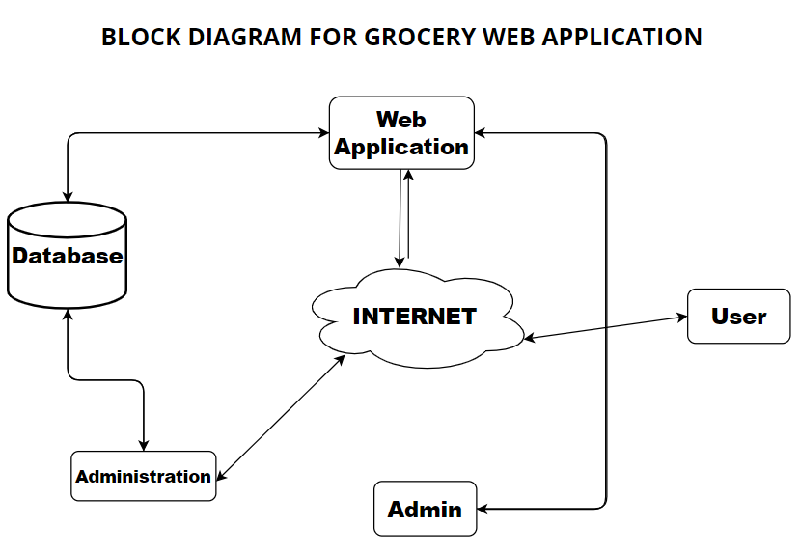

3.2 Hardware / Software Designing

The Grocery Web Application requires specific hardware and software components to function effectively. The following are the hardware and software requirements for the project:

**Hardware Prerequisites:**

Operating system: windows

RAM:8gb

Database: MySql DB

Library: JDK 1.6

Processor: Intel core

**Software Requirements:**

Intellij-version 213.6777.52

Postman-version 3.11.4150.0

Mysql-version 8.0.33

Mysql shell-version 8.0.33

Mysql workbench-version 8.0.33

Visual Studio Code-version 16.11.26

Angularjs-version 13.3.11

Node js-version 14.20.0

**4 EXPERIMENTAL INVESTIGATIONS**

During the development of the Grocery Web Application using Java Spring Boot, several experimental investigations were conducted to analyze and refine the solution. The investigations focused on various aspects of the application, including functionality, performance, security, and user experience. The following are the key experimental investigations carried out during the project:

* Functionality Testing: The application underwent extensive functionality testing to ensure that all the desired features and functionalities were working as intended. Test cases were created to cover different scenarios, such as user registration, product browsing, adding items to the cart, placing orders, and payment processing. The testing phase aimed to identify and rectify any functional issues or bugs in the system.
* Performance Testing: Performance testing was conducted to evaluate the application's response time, scalability, and resource usage under varying workloads. The application was subjected to simulated user traffic to measure its performance metrics, such as response time for different operations, throughput, and concurrent user handling capacity. This testing helped identify performance bottlenecks and optimize the application's performance for optimal user experience.
* Security Testing: The security of the Grocery Web Application was thoroughly tested to identify and address potential vulnerabilities. The application underwent penetration testing, vulnerability scanning, and code reviews to ensure robust security measures were implemented. Various security aspects, including user authentication, data encryption, secure payment processing, and protection against common web vulnerabilities (e.g., SQL injection, cross-site scripting), were assessed to enhance the application's security posture.
* User Experience Evaluation: User experience evaluation was conducted to gather feedback from users and assess the application's usability, intuitiveness, and overall user satisfaction. Users were invited to interact with the application and provide feedback on the user interface, navigation, product search functionality, cart management, and checkout process. This feedback was used to make necessary improvements and enhancements to enhance the user experience.
* Integration Testing: Integration testing was performed to validate the interaction and interoperability of different components within the application. The integration between the user interface, application logic, database, external APIs (e.g., for product recommendations, and address validation), and payment gateway was thoroughly tested to ensure seamless communication and data flow between these components.
* Stress Testing: Stress testing involved subjecting the application to heavy workloads and high user concurrency to evaluate its stability and robustness under extreme conditions. The application's behavior under stress conditions, such as sudden spikes in user traffic or high-volume data processing, was analyzed to identify any performance degradation or system failures. This testing helped identify and address potential bottlenecks or weaknesses in the application architecture.

**5 FLOWCHART**

The flowchart represents the control flow of the Grocery Web Application, illustrating the sequence of steps and decision points in the application's operation.

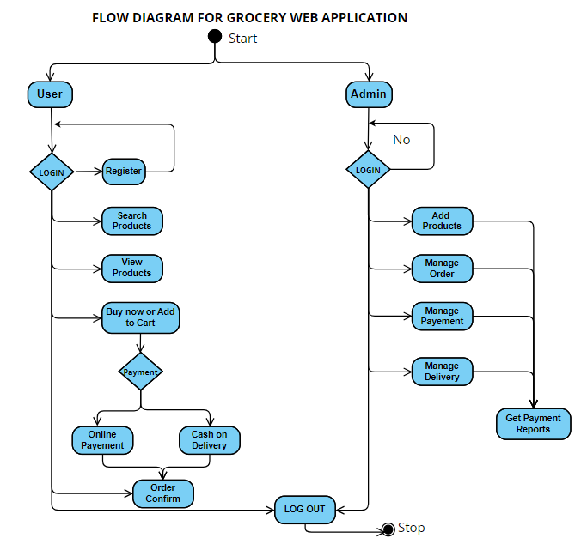

**6 RESULT**

* User Registration and Authentication:

1. Allow users to create accounts and log in to the application.

2. Implement user authentication and authorization to ensure secure access to features.

* Product Management:

1. Enable administrators to add, edit, and delete grocery products.

2. Include features for categorizing and organizing products.

* Product Listing and Search:

1. Display a list of grocery products with relevant information such as name, price, and availability.

2. Implement search functionality to allow users to find specific products based on keywords or filters.

* Product Details:

1. Provide detailed information about each product, including images, descriptions, nutritional information, etc.

* Shopping Cart:

1. Allow users to add products to their shopping cart for later purchase.

2. Provide features for updating quantities, removing items, and calculating the total price.

* Checkout Process:

1. Guide users through the checkout process, including providing shipping and billing information.

2. Implement validation and error handling to ensure accurate and complete information.

* Payment Integration:

1. Integrate with a payment gateway to enable secure online payments.

2. Support various payment methods such as credit cards, digital wallets, etc.

* Order Management:

1. Enable administrators to view and manage customer orders.

2. Provide features for order tracking, status updates, and notifications.

**7 ADVANTAGES & DISADVANTAGES**

The proposed Grocery Web Application developed using Java Spring Boot offers several advantages and brings numerous benefits to users. However, it also has certain limitations and disadvantages. Let's explore them below:

**Advantages:**

Convenience: The application provides users with the convenience of shopping for groceries online from anywhere and at any time, eliminating the need for physical store visits.

Wide Product Range: Users have access to a diverse range of grocery products, including fresh produce, pantry items, and household essentials, offering a comprehensive selection to choose from.

Personalized Experience: The application offers personalized experiences by allowing users to create accounts, save preferences, and receive recommendations based on their past purchases and preferences.

Efficient Order Management: Users can easily manage their orders, review their shopping carts, modify quantities, and track the status of their orders, ensuring a streamlined and organized shopping experience.

Secure Transactions: The application prioritizes the security of user transactions by utilizing encryption protocols and integrating with trusted payment gateways, ensuring the safety of sensitive information.

Responsive Design: The application is designed to be responsive and compatible with various devices, enabling users to access and use the application seamlessly on desktops, laptops, tablets, and smartphones.

**Disadvantages:**

Dependence on Internet Connectivity: The application heavily relies on Internet connectivity, making it inaccessible in areas with poor or no Internet connection.

Limited Physical Inspection: Users are unable to physically inspect or assess the quality and freshness of grocery items before purchasing, relying solely on product descriptions and images.

Delivery Time and Cost: The availability of delivery slots and associated delivery charges may vary, potentially leading to delays in receiving orders or incurring additional costs.

Potential Technical Issues: Like any software application, the Grocery Web Application may encounter technical issues, such as system failures, website downtime, or slow response times, affecting the user experience.

Learning Curve: Learning Curve: Users who are not familiar with online grocery shopping or technology may require some time to adapt to the application's interface and functionalities.

Limited Geographical Coverage: The application's availability and delivery services may be limited to specific geographic regions, potentially excluding users outside those areas.

**8 APPLICATIONS**

The Grocery Web Application developed using Java Spring Boot has versatile applications and can be utilized in various areas. Some of the key areas where this solution can be applied include:

Corporate Cafeterias and Canteens: Companies and organizations with cafeterias and canteens can implement the application to facilitate online ordering and payment for their employees. It simplifies the process of pre-ordering meals, reducing waiting times and improving efficiency.

Specialty Food Stores: Specialty food stores, such as organic food stores or gourmet food shops, can use the program to promote their unique items, facilitate online ordering, and provide their consumers with a personalized shopping experience.

Community Buying Groups: Community buying groups, often known as co-ops, can use the program to handle group ordering, bulk purchasing, and seamless member collaboration. It streamlines the collective purchasing process and ensures order management efficiency.

**9 CONCLUSION**

In conclusion, the creation of the Grocery Web Application utilizing Java Spring Boot in the context of modern application development has resulted in a solution that provides consumers in the grocery shopping domain with convenience, efficiency, and personalized experiences. The Java Spring Boot framework was effectively used in the project, allowing for the development of a robust and scalable application.

The Grocery Web Application offers various benefits, including convenience, a vast product selection, personalized experiences, fast order management, secure transactions, and responsive design. It allows consumers to buy groceries online, saving time and giving them more flexibility. The application does, however, have several limitations, including reliance on internet connectivity, limited physical inspection, delivery time and cost considerations, potential technological challenges, a learning curve, and restricted geographical coverage. These limitations highlight areas that require attention and continuous improvement to provide an optimal user experience. Overall, the Grocery Web Application has proven to be a valuable solution for online grocery stores, supermarkets, local grocery shops, mobile grocery delivery services, corporate cafeterias, specialty food stores, and community buying groups. Its versatility allows it to cater to a wide range of businesses operating in the grocery industry.

The Grocery Web Application's successful implementation showcases the power of the Java Spring Boot platform and modern application development practices. Based on user input and emerging technology, further upgrades and optimizations can be made to continuously improve the application and suit the increasing demands of users in the dynamic grocery shopping landscape.

**10 FUTURE SCOPE**

The Grocery Web Application built using Java Spring Boot provides a strong basis for future expansions and improvements. As technology and user expectations grow, there are various areas where future additions to the application can be implemented. Here are some prospective future development areas:

* Developing a mobile application version of the Grocery Web Application helps broaden its reach and gives a more smooth and optimized user experience on mobile devices. This would include using technologies like React Native or Flutter to create cross-platform mobile applications.
* Integrating the application with smart home equipment, such as voice assistants or IoT-enabled refrigerators, can give users a more intuitive and convenient grocery shopping experience. Users could use voice commands or barcode scanning to add goods to their shopping lists or place orders.
* Advanced Recommendation Engine: Improving the application's recommendation engine can provide customers with personalized and targeted product recommendations based on their previous purchases, browsing behavior, and preferences. To improve the accuracy and effectiveness of product suggestions, machine learning algorithms and data analysis approaches can be used.
* Real-time Inventory Management: Using real-time inventory management guarantees that users have access to the most up-to-date product availability information. This reduces the likelihood of customers ordering out-of-stock items and improves the overall customer experience.
* Integrating the program with prominent social media sites allows users to share their shopping experience, post reviews, and propose products to their friends and followers. This can assist in raising brand recognition and attracting new customers.
* Enhanced Delivery Tracking: By integrating with GPS technologies and giving real-time updates, users will be able to monitor their orders more accurately and effectively. This has the potential to improve transparency and client happiness.
* Multiple Payment Options: By integrating with various digital payment platforms, mobile wallets, and cryptocurrencies, you may give users greater flexibility and ease throughout the checkout process.
* Customer Support and Chat-bot Integration: Integrating a chat-bot or AI-powered customer support system can help users resolve problems, provide recommendations, and address any issues that may arise throughout their buying experience.
* Social Responsibility and Sustainability: By incorporating features that promote sustainable practices, such as highlighting eco-friendly products, supporting local farmers, or providing information on product carbon footprints, the application can align with the growing demand for socially responsible and sustainable shopping experiences.
* Expansion to New Geographical locations: Making the application available in new geographic locations can boost its user base and cater to a larger audience. Adapting the application to local languages, currencies, and regulations would be required.

**11 BIBLIOGRAPHY**

**APPENDIX**

* Home Page

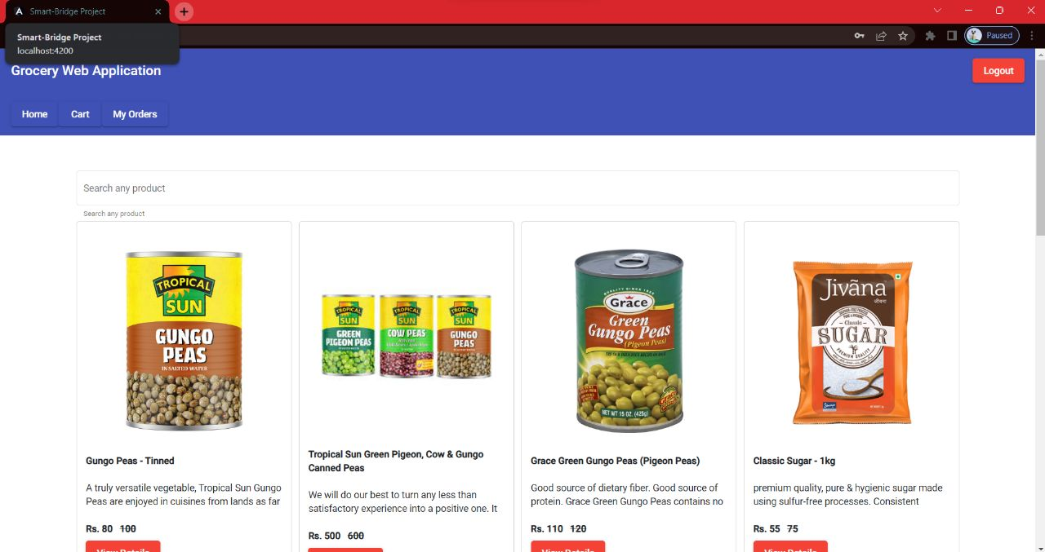

* View of Product

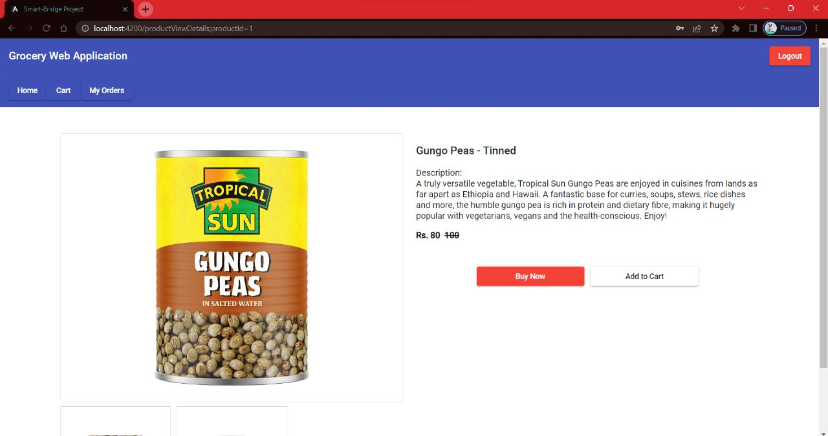

* Payment Details

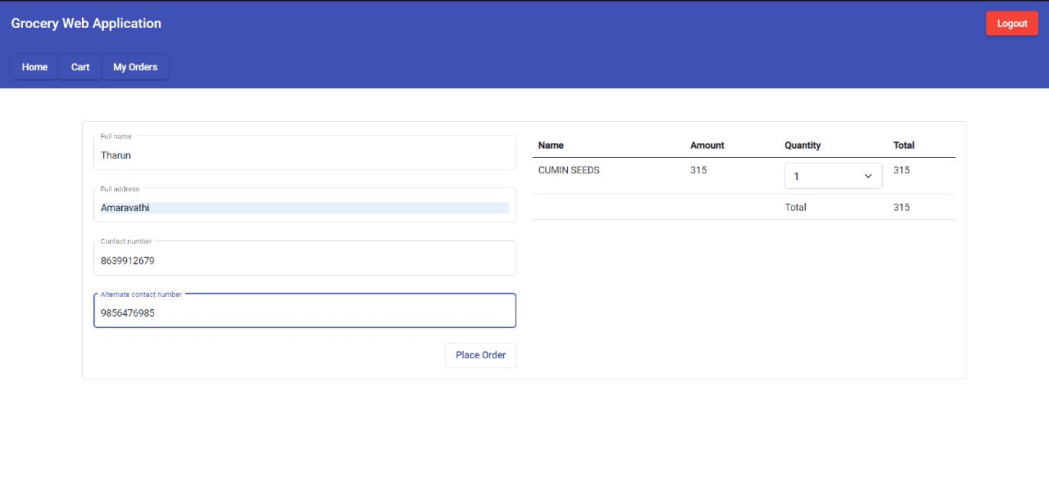

* Order Details

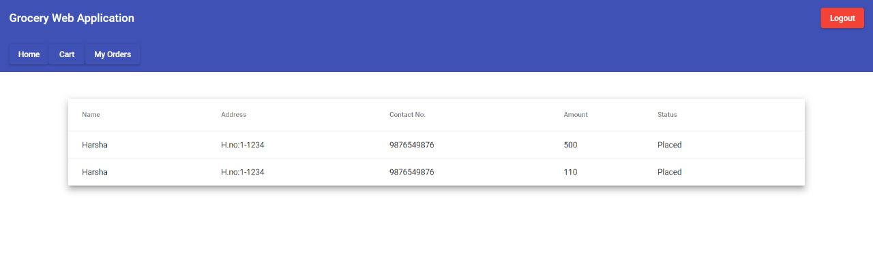

* Cart Option

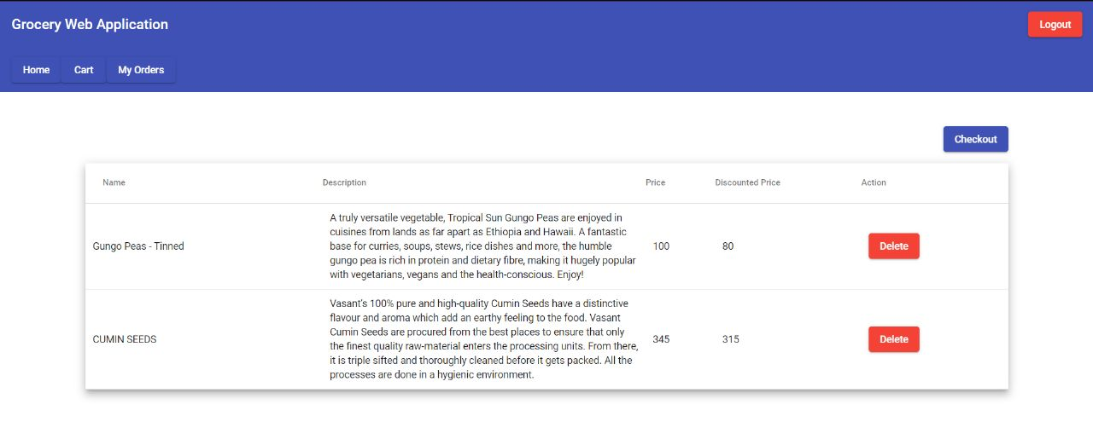

* Login Page

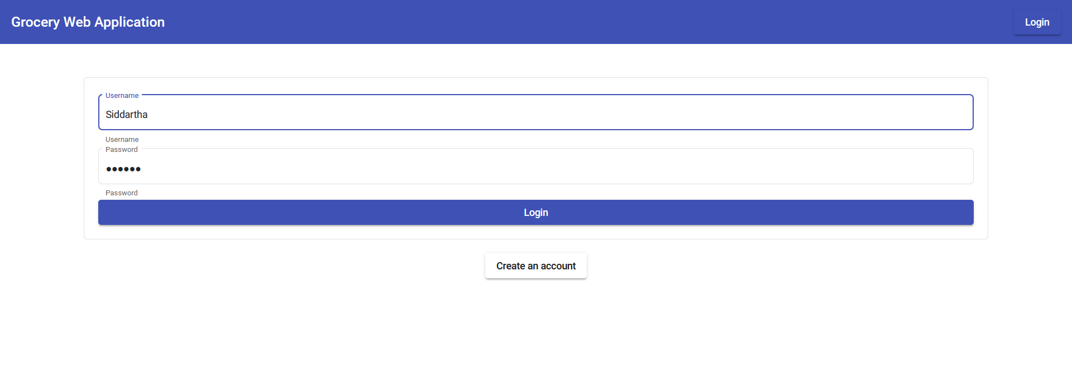

* Register Page

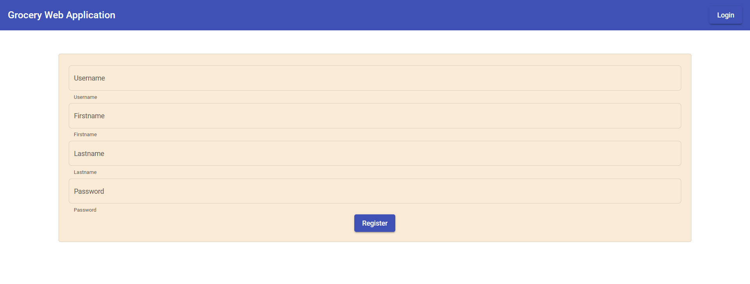

* Database:

